**Ad-Hoc Ansible Commands**

ansible web -i inventory -m ping

ansible all --list-hosts

ansible web -i inventory -m command -a 'df -hk'

ansible-doc -l | more | wc -l

ansible-doc yum

ansible web -i inventory -m user -a "name={{username}} password={{ 'password' | password_hash('sha512') }}"

ansible web -i inventory -m yum -a "name=httpd state=present"

ansible web -i inventory -m service -a "name=httpd enabled=yes state=started"

ansible web -i inventory -m yum -a "name=httpd state=absent"

ansible web:db -i inventory -m service -a "name=httpd enabled=yes state=started"

ansible db -i inventory -m setup -a "filter=ansible_mounts"

ansible all -i inventory -m setup --tree ./setup

ansible prod -i hosts -a "hostname"

ansible prod -i hosts -a "df -hk"

ansible localhost -m debug -a 'var=groups.keys()'

ansible prod -m stat -a "path=/etc/environment"

ansible prod -m copy -a "src=/etc/hosts dest=/tmp/hosts"

ansible prod -m fetch -a "src=/etc/hosts dest=/root"

ansible prod -m file -a "dest=/tmp/test mode=644 state=directory"

ansible prod -m file -a "dest=/tmp/test state=absent"

ansible prod -m shell -a "tail /var/log/messages | grep ansible-command | wc -l

1.

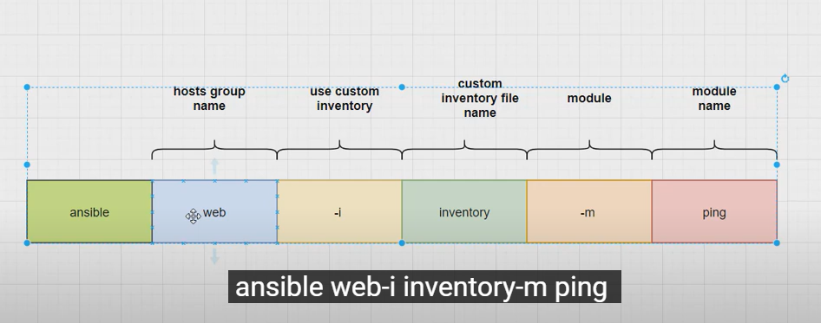

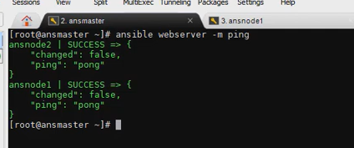

2.

3.

uninstall httpd state=absent

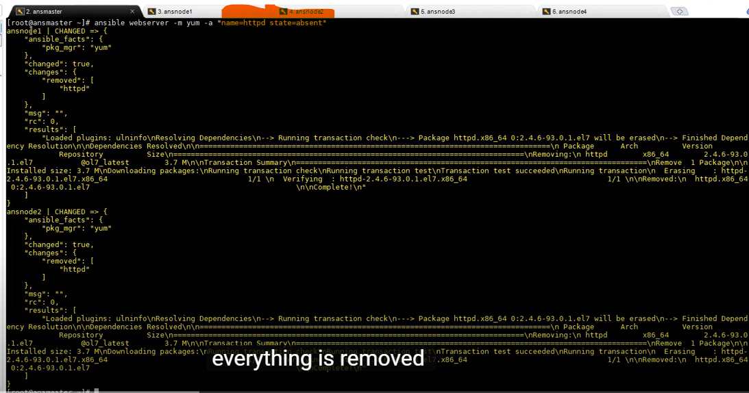

4.

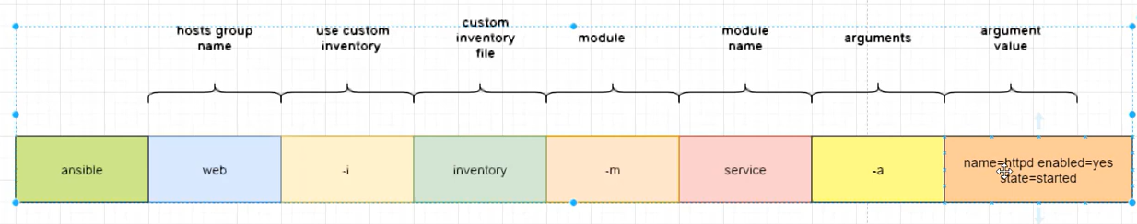

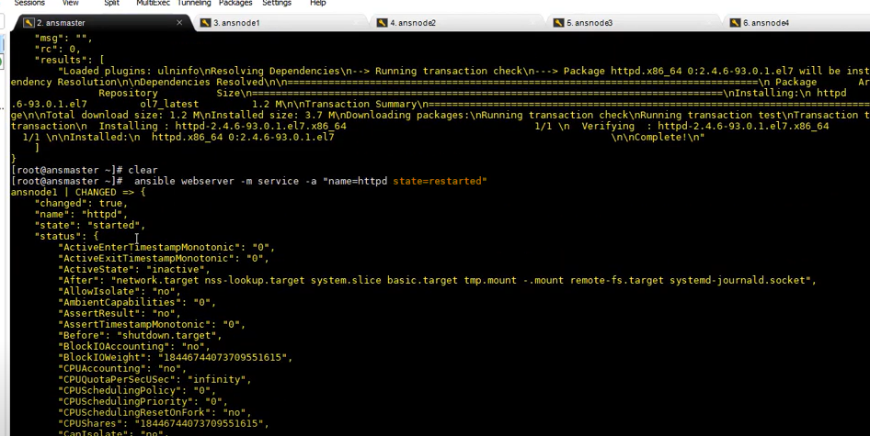

Shell module:

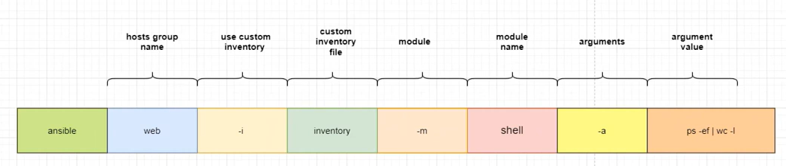

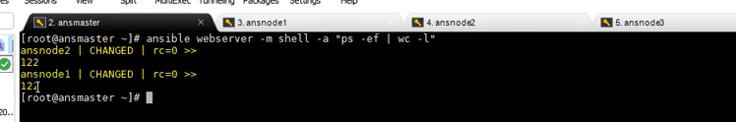

Copy module: (source to destination)

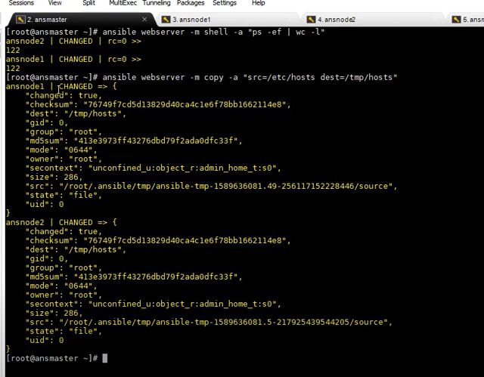

Fetech module: ( destination to source)

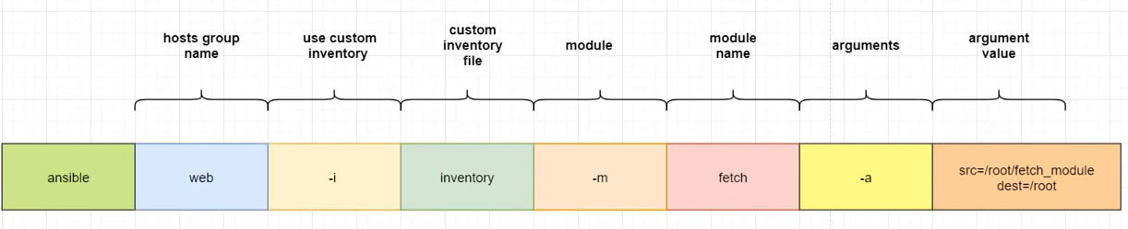

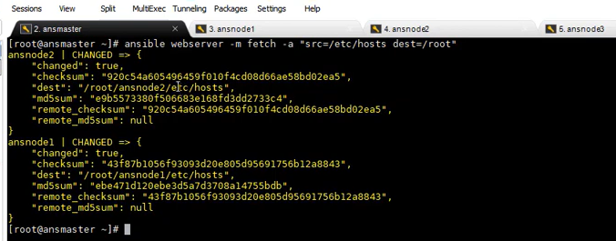

File module:

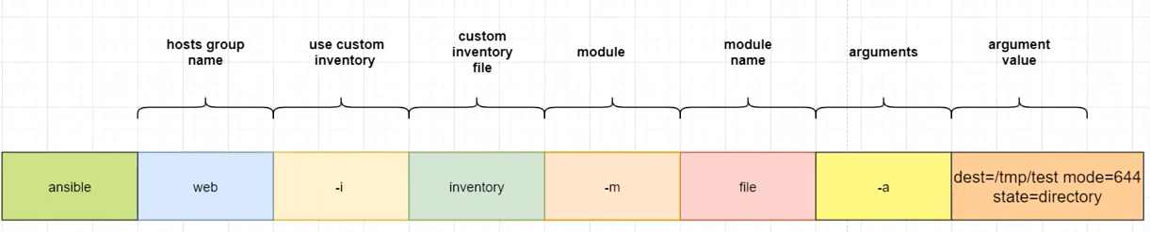

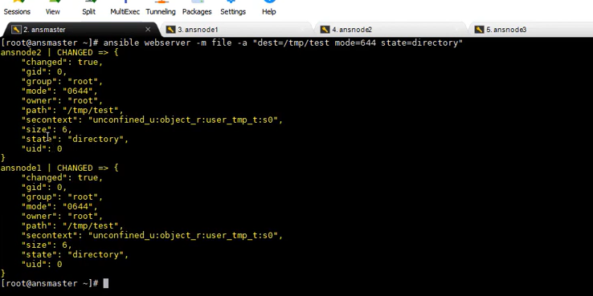

Setup module(get computer details)

